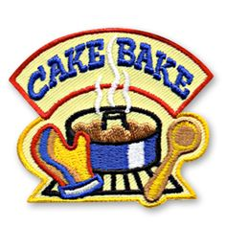ANNUAL PARENT/SON CAKE BAKE AUCTION
Monday March 27, 2017 * 6:30PM
Pack 208 Cub Scouts are invited to bake a cake with the assistance of their Akela (parent, guardian, and grandparent) and enter it into the auction. Please invite any family in on the fun. All cakes must be baked at home (no store-bought cakes) and decorated with scout help and input.
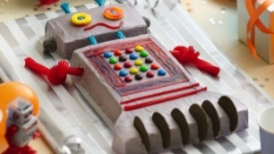Cakes will be Scout-judged for prizes for each theme. Feel free to BE CREATIVE! Themes are listed below for each den.
Lions: Robot Cake- Lions can create a cake showing creativity and imagination, how just like people, no two Robots are alike.

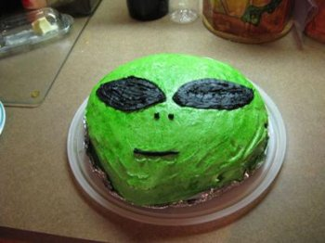
Tigers: Outer Space Cake- There’s a big world out there far past the stars and scouts like to be out in it having adventures. Tigers can create a cake that shows how they see Outer Space.
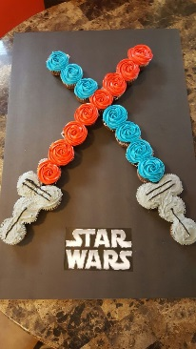
Wolves: Movie themed Cake – Movies allow us to travel through space and time, meet superheroes, increase knowledge in history, find courage, and learn about life. It’s a fun silly reality. Inspirational movies helps us to become brave, clever, loyal, determined etc. which helps us to become positive – minded people. Wolves can create a cake that represents what they’ve learned while having fun.
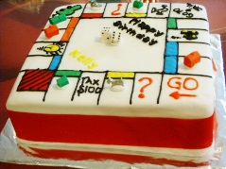
Bears: Board Game Cake- Cub Scouts are busy boys with many interests. Something every family enjoys is to be with each other with no goal in mind beyond the joy of spending time together. The Bears will share this interaction covered in frosting.
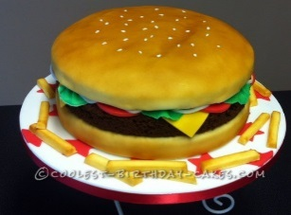
Webelo: Cake shaped like other food- The opportunities to experience scouting while trying something new are endless. Keeping your imagination sharp is key to making even the most challenging obstacle fun. Have fun just being creative taking your favorite foods and turning them into a delicious cake.

